**Aws lambda Trigger Step Funtion**

1. **Request**
2. **Response**
3. **Fail**

**Go to Aws Lambda and create three Lambda function for Request, Response, and Fail**

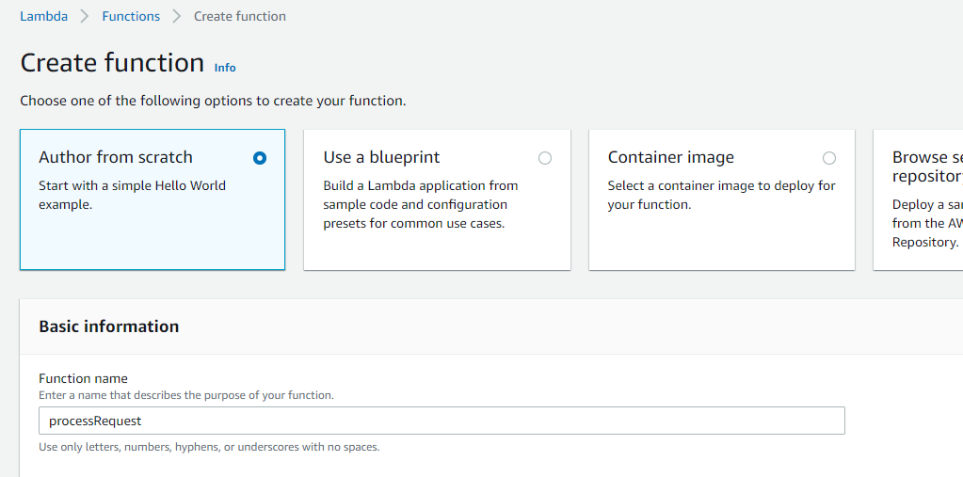

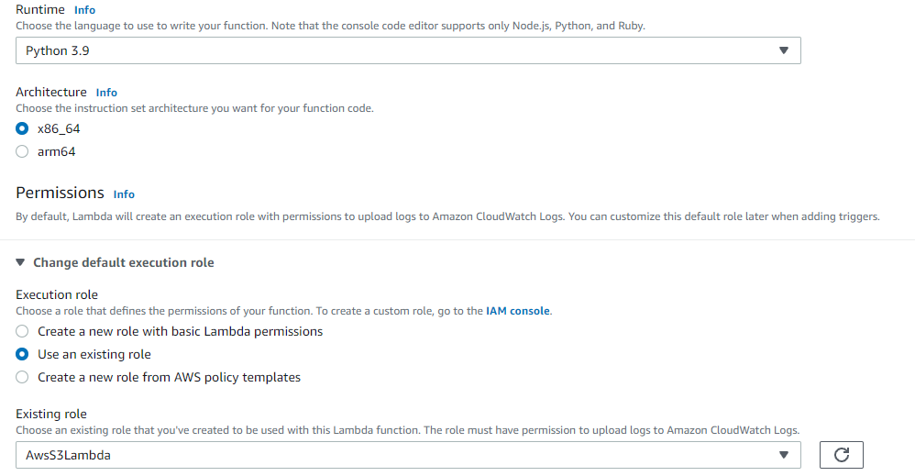

Attach the role that allows Aws stepfunction full access, Aws S3 full Access, CloudWatch Full Access

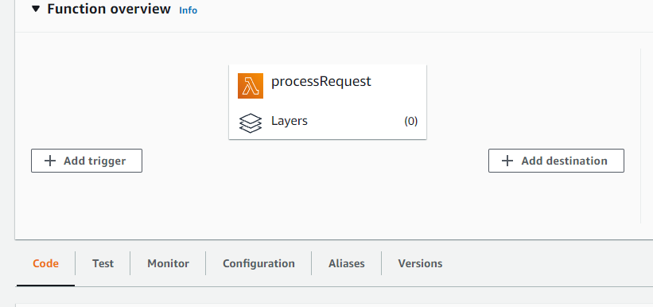

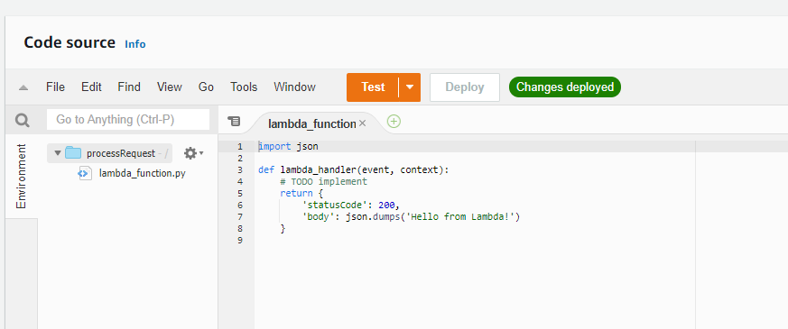

Now add your code and deploy it

<https://github.com/vishnuvs369/Aws-Python/blob/main/AWS-stepFunction-Triggering-From-Lambda/process_request.py>

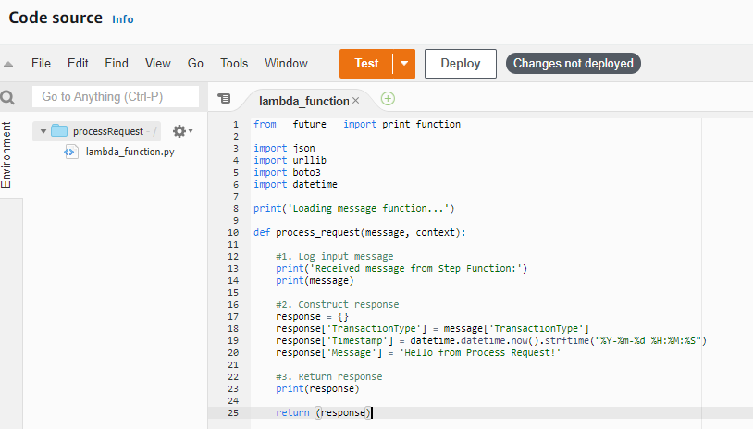

Now edit handler name in Runtime settings and save it

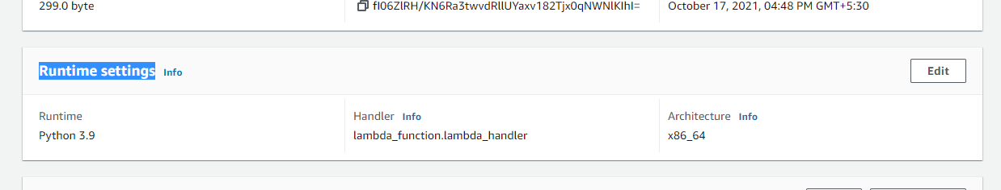

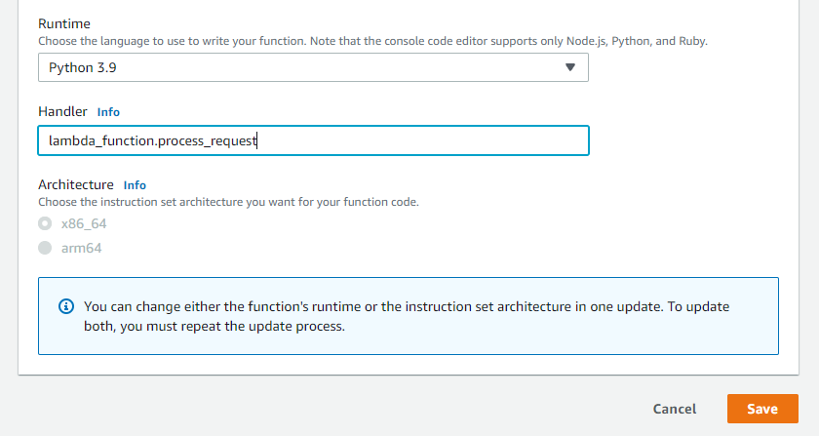

Similiarly create lambda function for Response and Fail

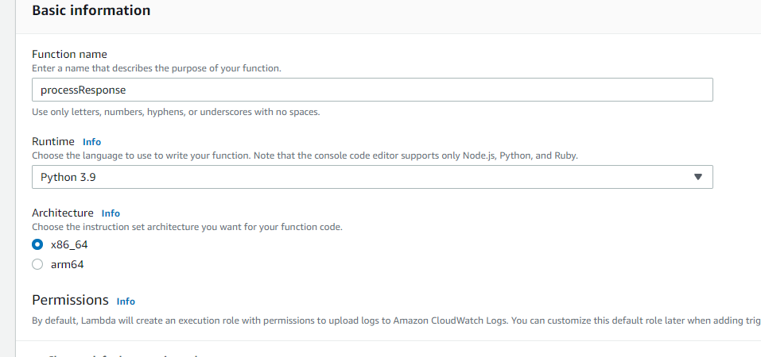

<https://github.com/vishnuvs369/Aws-Python/blob/main/AWS-stepFunction-Triggering-From-Lambda/process_response.py>

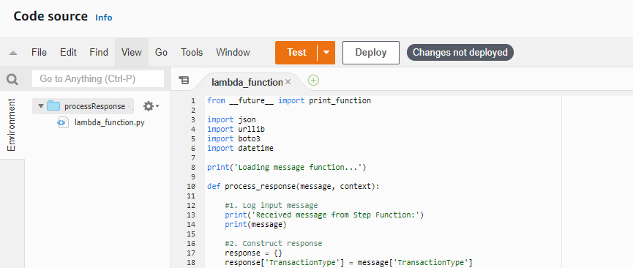

Change the name of handler in runtime settings

Now create lambda function for Fail

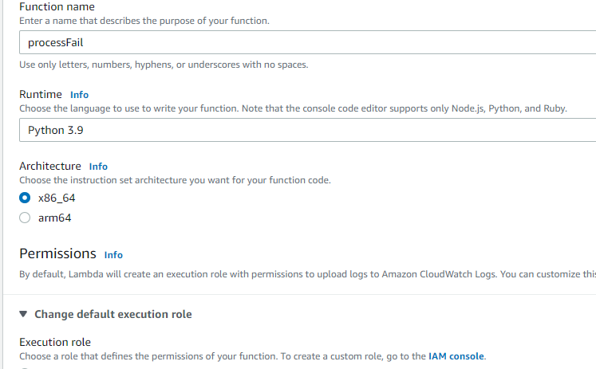

Add your Process Fail code there

<https://github.com/vishnuvs369/Aws-Python/blob/main/AWS-stepFunction-Triggering-From-Lambda/process_fail.py>

Change the handler name too

Our three Lambda function is created now

Now go to Aws Step function

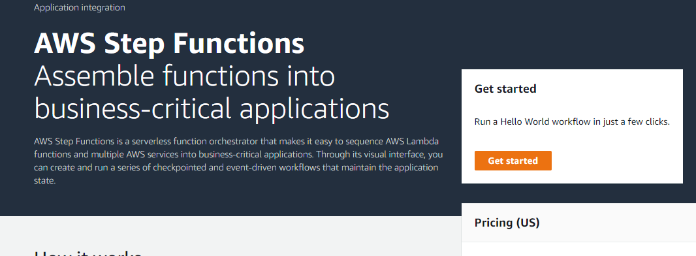

Go to state machine and create state machine

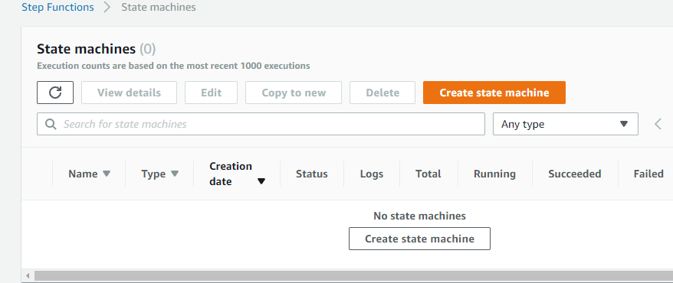

Choose this

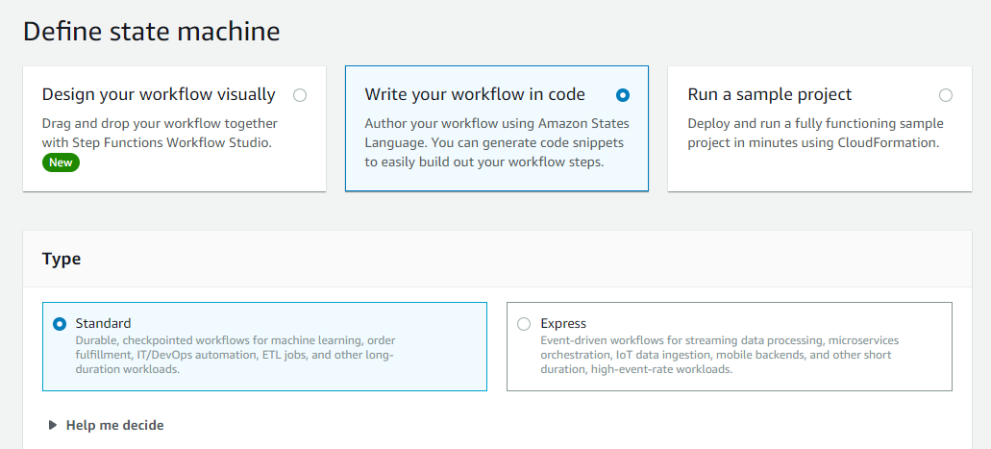

Now add your work flow code

https://github.com/vishnuvs369/Aws-Python/blob/main/AWS-stepFunction-Triggering-From-Lambda/MyStateMachine

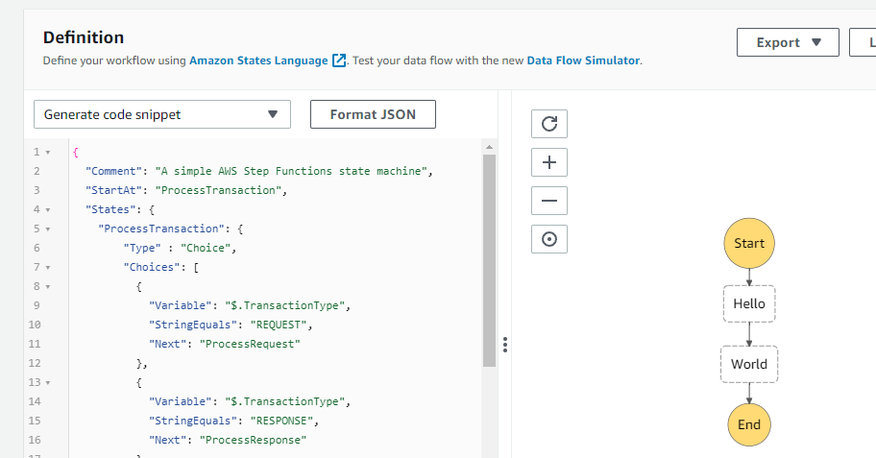

Just refresh you can see your flow

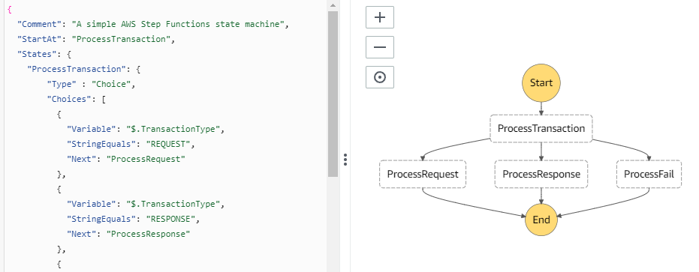

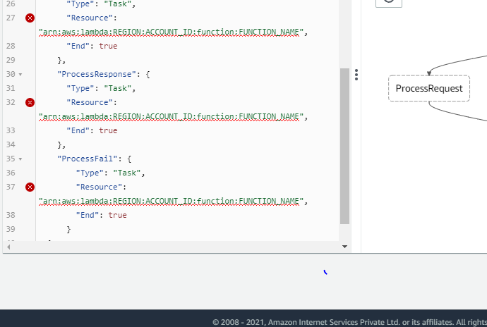

You can see errors there, Now we have to add the ARN for respective lambda function

After adding ARN the error will gone

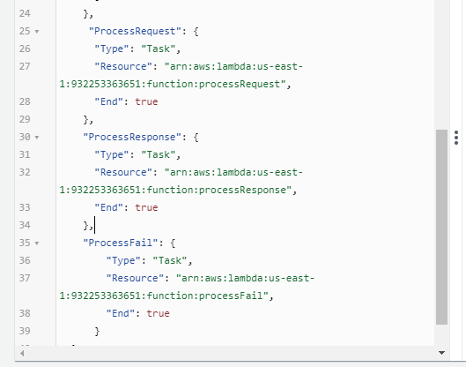

Now click on next and Name your machine and choose a Stepfunction full access role and create your machine

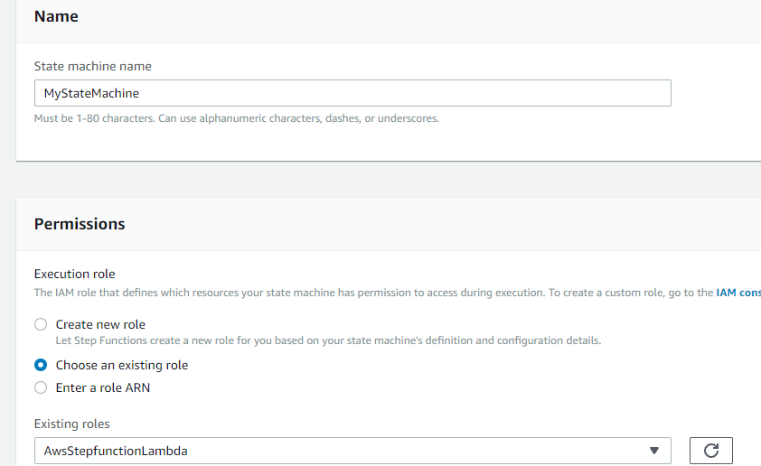

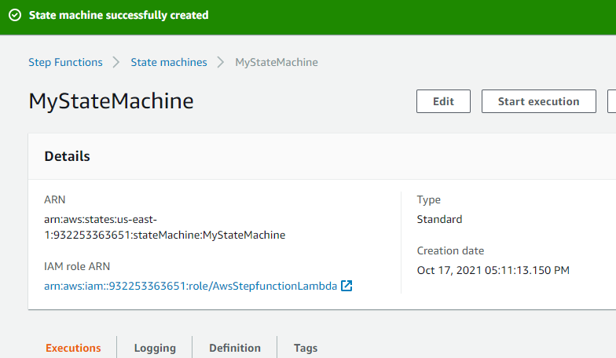

Now we can test the execution, Start an Execution

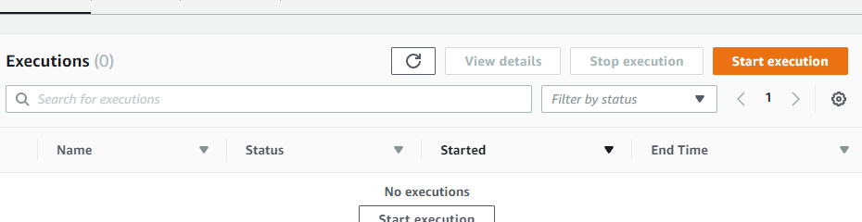

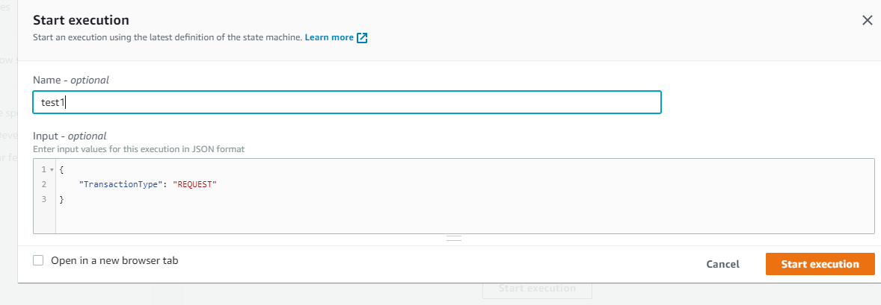

Here we add a json input of

“TransactionType” : “REQUEST”

If it is success , it will go to Request Process otherwise fail

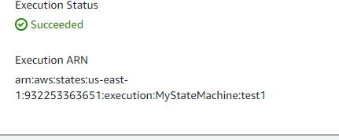

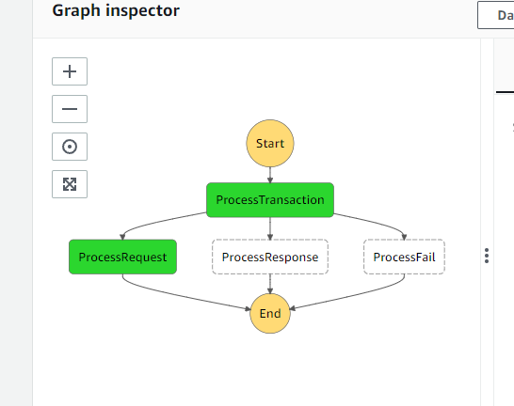

If the TransactionType is Response then it will go to Process Response

**Now using a Lambda function we can trigger Step function**

For that we need to create another lamba function

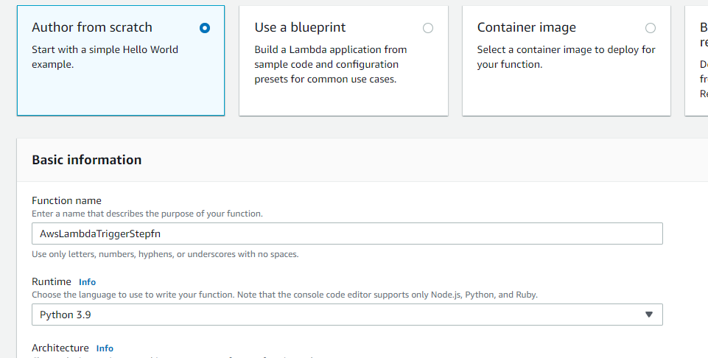

Attach stepfn full access role And create lambda function

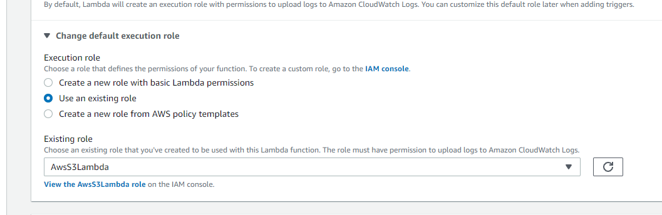

Now Add your Lambda fn code there

https://github.com/vishnuvs369/Aws-Python/blob/main/AWS-stepFunction-Triggering-From-Lambda/lambda_function.py

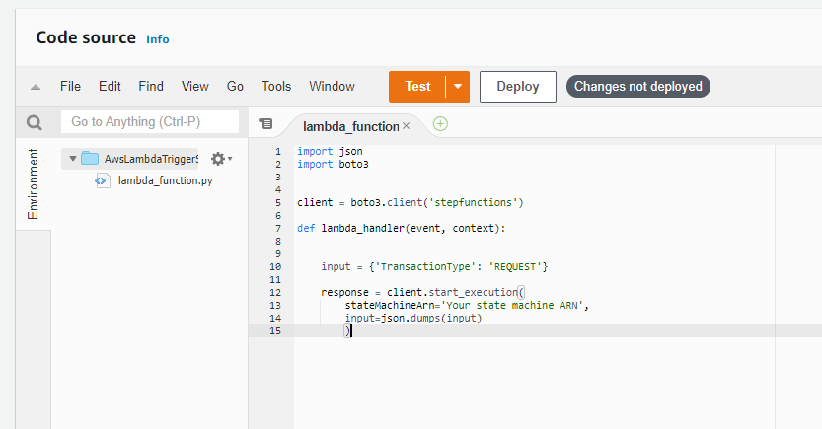

Replace Statemachine ARN with your State Machine ARN

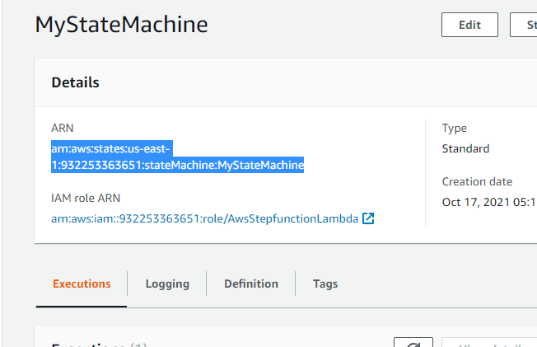

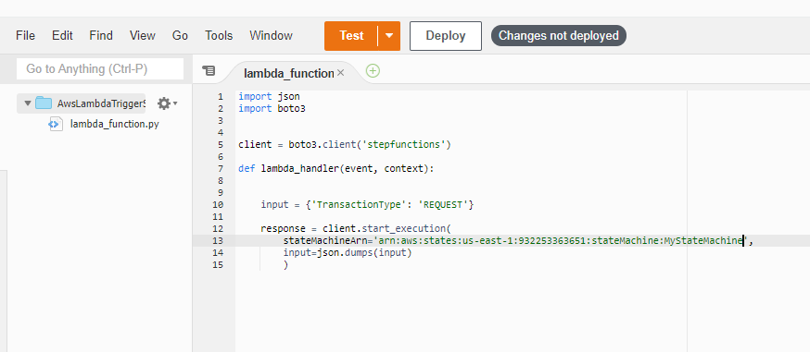

Now Deploy the changes and test it

Now we hardcoded the transaction type as REQUEST, if it success Lambad function will trigger to Request stepfunction

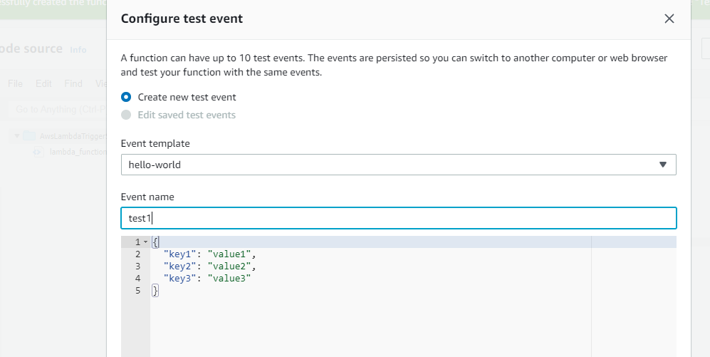

Run the test

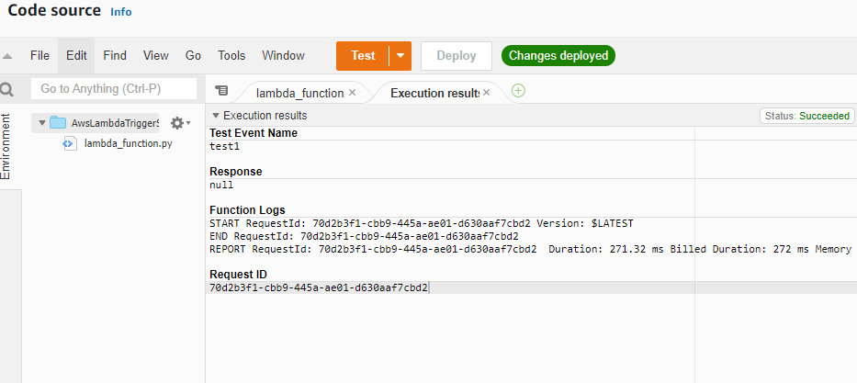

Test runned, now go step function

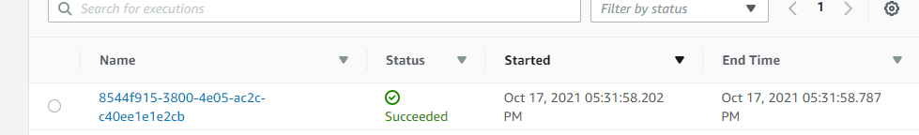

You can see the new step function with success check that…you can see the graphical representation

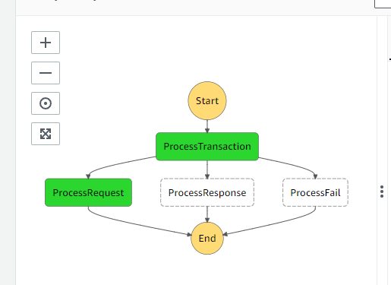

Request is executed success fully, if the input type we given in Lambda function is Response it will trigger to response